Critical Reflection

Sem 2, AY 2022/2023

Landing Page

**Getting Comfortable with the Uncomfortable**

Over the past four years, I’ve discovered the beauty of finding comfort in the uncomfortable. I embarked on a journey filled with novelty and change, encountering new cultures, making new friends, dealing with new viruses, and grappling with new ideas. Yet, as much as it was a journey of newness, it was also a journey of oldness. I had to bid farewell to my hometown, lost some old friends, questioned my past assumptions, and simply grew older.

My posts paint glimpses of my life here, as I found communities within communities, depth in hollow platitudes, and reason in old biases. While I choose to present them in the order they were written, they can be read in any order.

In finding micro-cultures in Singapore and USP, I was pushed out of my comfort zone and forced to confront my own biases and assumptions. Through this discomfort, I was able to see the world in a new light and gain a deeper appreciation for the diversity of human experience.

As I progressed in my studies, I found that my passion for computer science was not enough on its own. At the same time, I took a class in biochemistry, which introduced me to an ethical motivation for pursuing scientific research. This was a challenging and uncomfortable experience at first, but it led me to see the impact of my work in a new light, which imbibed my computer science work with a deeper sense of purpose and responsibility.

And in articulating why authoritative teachers are better than facilitative teachers, I was forced to confront my own past experiences and biases. It was uncomfortable to challenge my own assumptions, but it ultimately led me to a greater understanding and appreciation for the value of structured, authoritative teaching.

As I look back on my university years, and especially in my little corner of 22 College Ave. East, I'm struck by how much I've grown and changed. There were certainly challenges along the way, but it was through facing those challenges that I found the most rewarding experiences. I learned that stepping outside of my comfort zone was necessary to truly grow and discover my passions. It was uncomfortable at times, but it led me to where I am today. And now, as I look forward to the future, I know that I will continue to seek out new challenges and opportunities for growth, no matter how uncomfortable they may be.

Critical Reflection

Sem 2, AY 2022/2023

Learning In- and Outside the Classroom.

**Blue Ketupat on a Red Dot**

When my cab from Changi Airport arrived at Cinnamon College on the night of 27th June, I was a stranger in a foreign land. Since I was an international student, I knew no one in Singapore -- or at the University Scholars Programme (USP) which is housed at Cinnamon College. During the ensuing weeks, when I played, bantered or danced with my new *ketupat[1]*-donning “sinkie” friends [1], I wondered which habits of theirs’ were USP-specific and which were Singaporean. Were my orientation mates at USP speaking an odd language with “lahs” and “lors” because of an inside joke? Do all Singaporeans love solving 4d chess puzzles? Three-and-a-half years later, I’ve learnt that the answer to “is *this* Singaporean or USP?” are especially illuminating – and questions of this form have helped me learn about Singapore through the USP lens and vice-versa. More broadly, as someone who hails from the world’s most populous country (India), I’ve learnt to value the importance of micro-cultures inside mini-cultures – of blue ketupats on red dots – and that size is deceptive -- micro-cultures can prove to be far more complex than their bigger counterparts [2]. The two key experiences that helped me tease these out were writing an article about USP’s cultural decline, and reading a module about Singapore’s nation-building story.

As a community of just over 800 people, USP was an easy community to fit into. My seniors at USP often touted USP’s culture as akin to that of Oxford Union: a safe, semi-public space to try out funky new ideas, spar with each other, and pursue curious inquiry. Interestingly, it was described as an *oasis or bubble within an often sterile Singapore* whose leaders thought that even “poetry [was] a luxury.” The late USP director agreed [3]. However, two-years and a pandemic in, I felt that something was not right – there was little sign of the advertised “dance of ideas” at a community-level. In the summer of 2020, I tried to uncover whether these hear-say rumours about USP were true. My amateur historiography saw me trawl through old articles, Facebook posts, and Telegram messages, and even some Python programs. It culminated in an article entitled “The Cinnamon Scroll: A Look Back at the Decline of Ideas in USP.” To my surprise, in the process of learning about USP’s history, I learnt a lot about Singapore, and how to convince Singaporeans. When I first pitched my thesis to friends in the USP dining hall (or over chat), they weren’t thoroughly convinced, since most people felt I was victim to recency bias:



At the behest of a (Singaporean) friend, I tried to shield myself from recency bias, and analyzed data about the number of articles published by *The Cinnamon Roll* (USP’s student publication), and importantly, a wordcloud summarizing the most frequent topics that USP students discussed on Battle Royale, a community-wide Telegram group:

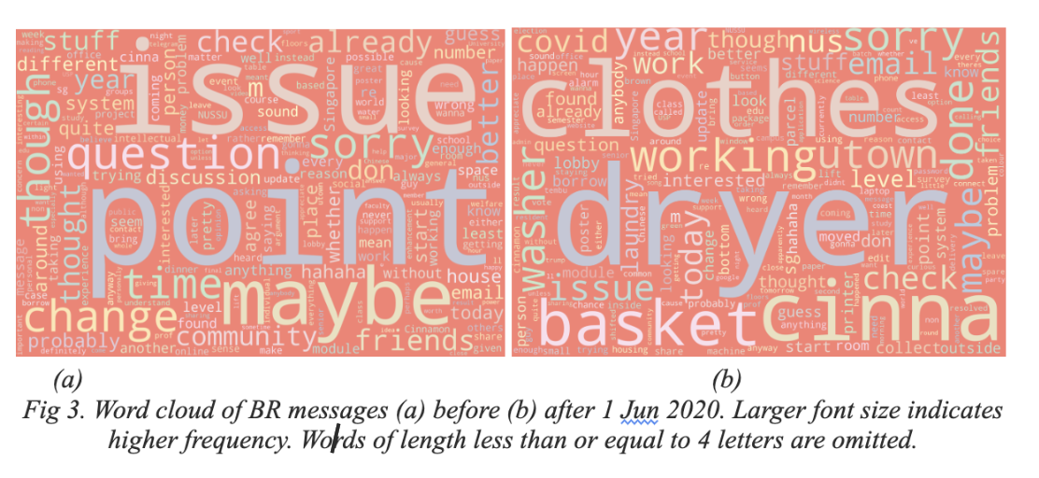

In the above graphic, I chose to show both periods (pre- and post 1 June 2020) are shown using the same salmon-pink colour. The reason I chose identical colours for the two palettes was because I wanted to prioritize content over presentation, i.e. let the stark contrast in topics speak for itself. I felt that the lack of contrast would resonate better with USP students, who are dopamine-conditioned to enjoy when they are able to discern true substance over superficial difference.

Far from being a safe space, I learnt that back in 2011, USP was a toxic atmosphere for low-income students, as the link to Koh Choon Hwee’s article shows below. At the time, I used the term “provocative” to distinguish the article from an apathetic languor that is often ascribed to Singaporean politics:

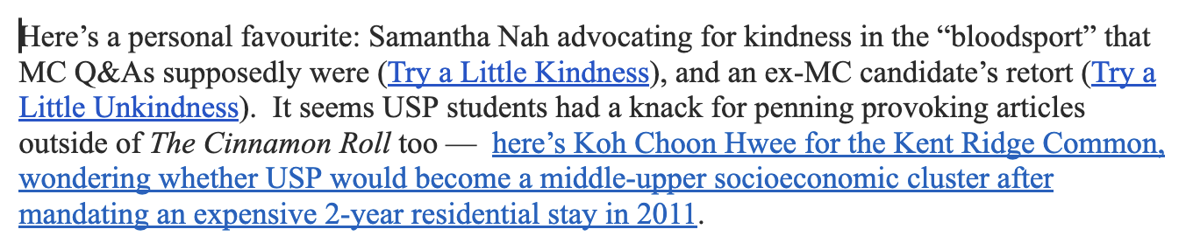

At the behest of a professor, I emailed Choon Hwee (now Prof. Koh) to set up a Zoom call and discuss USP’s history. I chanced upon her prediction that USP would soon become a “bourgeoise bubble” (a classist term not often used in Singaporean discourse) .

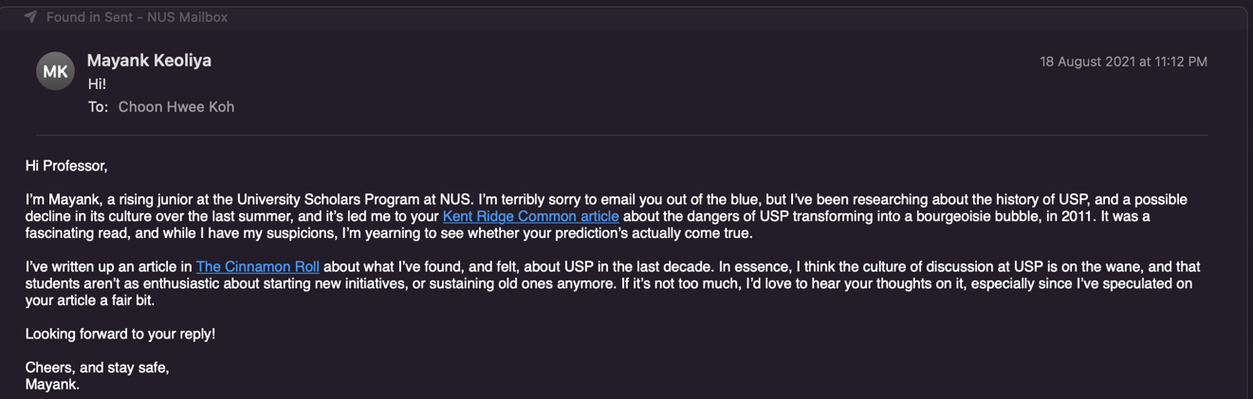 During my conversation with her, I had my first full realization that indeed, USP was a microcosm of several things: “Singapore, foreign interference, Eurocentrism” – and how it led to Prof. Koh’s friend being bullied by her peers for the “fault” of being from a low-income household. I was shook heavily, since I realized that her article (and several other articles written for USP’s student publication ) were not merely “provocative” – they harboured a kernel of truth which was true to USP … and to Singapore too, as I’d soon find. 

Clearly, writing my article about USP raised several questions: How does the socio-economic background or privilege of USP students compare to that of Singapore? How does that affect USP’s culture, politics and its idiosyncrasies? Are USP students (myself included) incremental reformists rather than radical visionaries, and if so, is it because they hail from privileged backgrounds – or is it because the Singaporean educational system has socialized them? A couple of weeks after publishing my article, I embarked on a module entitled “Making of a Nation,” (herinafter, MOAN) which shed light on these questions.

In writing my final essay for MOAN, which involved analyzing a series of five films and documentaries, I realized that Singaporeans often speak of the socio-economic system, of government and its decisions as invitable and pre-determined:

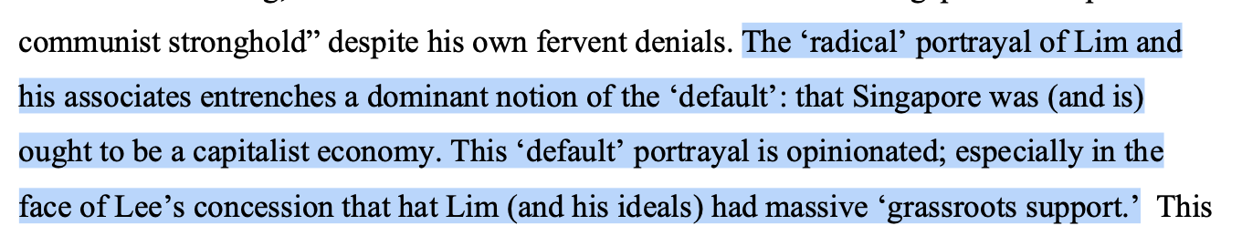

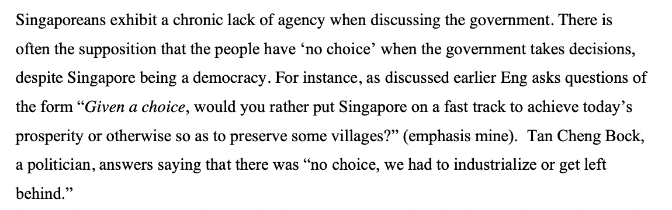The above excerpts critique Lim Chin Siong’s characterization as “radical”, akin to how I’d (erroneously and unfortunately) described Prof. Koh’s criticism of USP’s socio-economic as “provocative” initially. Furthermore, I found a stark contrast between the lack of political agency and USP’s politics in the past:

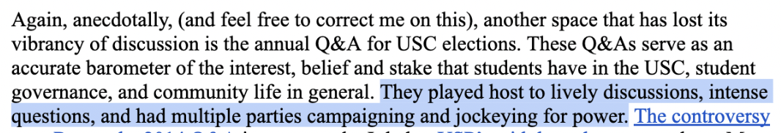

Interestingly, both Singapore and USP “played host to lively discussions” and “multiple parties … jockeying for power” in their infancy. However, as they both matured and stratified, there arose a general sense of apathy and lack of contestation, made worse by “bourgeoise bubbles” in Singapore and USP.



The interplay of USP and Singapore has been of great personal import to me, since a majority of the Singaporeans I know are affiliated to the USP in some way or another. I emerged from from 2021 with a fuller understanding of what is unique to USP and Singapore’s past (“criticism of the system”, “contestation” and lively debate”) and to Singapore’s present (“rationality”, “emphasis on quantitative metrics”), and what is common: a cutting sense of intellectualism, pragmatism, and change.

Matric Number: A0200908M

(1015 words)

**Appendix**

My intended audience is a student, professor or alumnus of USP.

Below, I’ve attached some supplementary pictures to provide the reader with additional context.

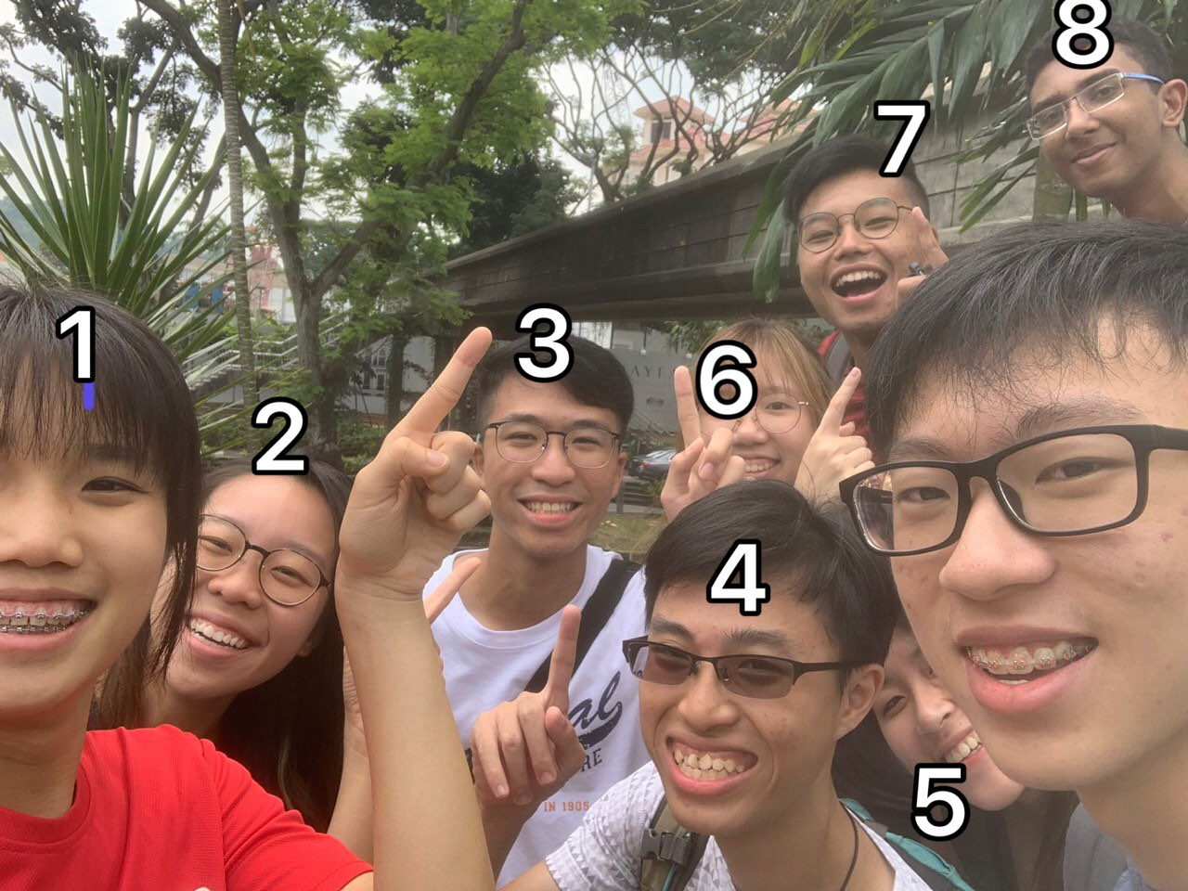[1] 7 orientation-mates and I (labelled #8) wearing red and white, and going out for bubble tea on National Day. The *ketupat* is an affectionate term used to describe USP’s logo.

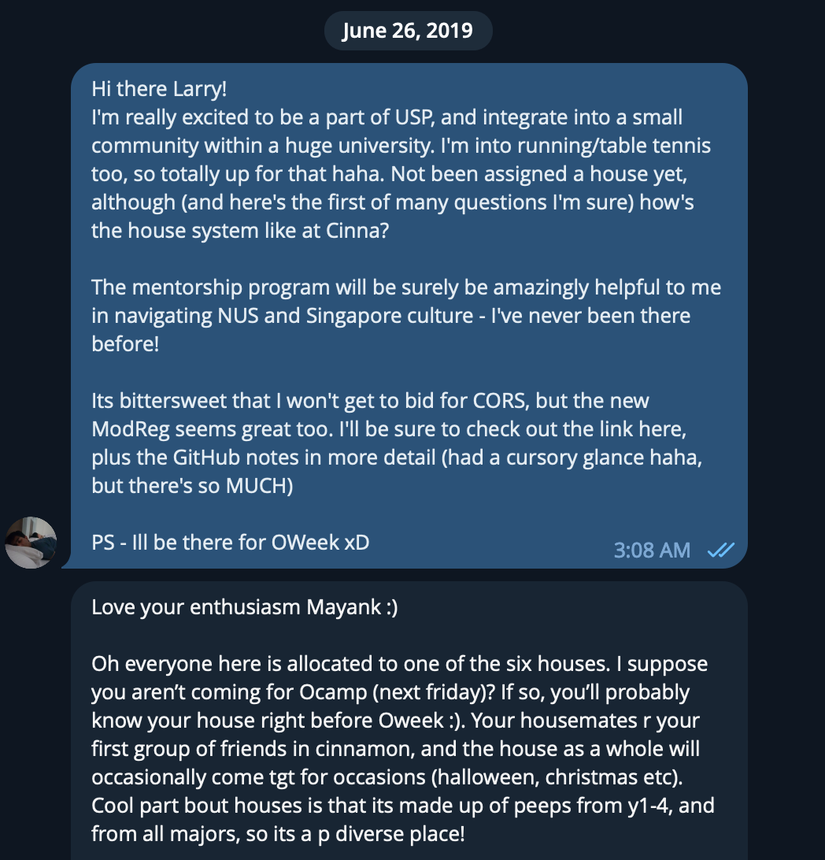

[2] My first conversation with Larry, my mentor, about USP, “a small community within a huge university.”

Critical Reflection

Sem 2, AY 2022/2023

USP & Home Faculty Learning

**On Becoming An Ethical Tech-bro**

Ask any USP student or NUS admin staff about USP, and their answer is bound to contain a *vanilla platitude*: **being exposed to an interdisciplinary background**. The platitude has been mercilessly beaten to death in countless interviews, dining hall conversations and reflections [2]. The platitude has become devoid of meaning. It is so vanilla that it borders on becoming conventional, a quality that USP especially abhors.

The conventional wisdom of USP’s platitude goes thus: in a complex world, complex problems require complex solutions harnessing the power of different disciplines. Enter USP and its “exposure to different disciplines” and *voila*, you have a formula for helping students solve complex problems! But what form does “exposure” take? Is exposure simply all about adding to a corpus of domain knowledge by taking 12 classes?

In this essay, I will tell you the story of how I discovered an ethical idiom in my major (computer science) courtesy exposure to a different discipline at USP. My story made me realize that the key purpose of “exposure” is to tease out idioms from a discipline and apply it to other disciplines.

Every discipline, even a nascent one like computer science, has its own idioms, mores or subcultures. Each idiom’s idiosyncrasies reflect the shape of the discipline and its epistemology. For instance, some common idioms in computer science are (arguably) the zeal for precision, the relentless desire for impact, the tendency to abstract concepts into layers, and so on. Idioms can be wrongly identified ofcourse; USP’s vanilla platitude might simply mean “learning for learning’s sake” to the undiscerning eye.

Of course, we tend to get especially attracted to certain idioms more than others. Personally, I’ve always been attracted to the “hacker” aspect of computer science, which led me to join a group called NUS Hackers at the School of Computing. “Hacking” per NUS Hackers was about learning-through-making, and is wholly unrelated to the popular conception of hacking as breaking into computers [3]. Hackers are often described as “techbros” too.

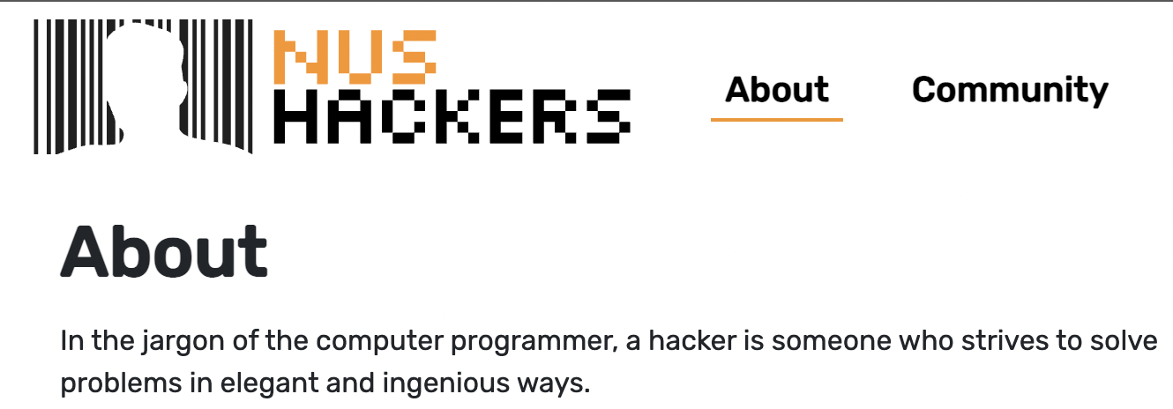

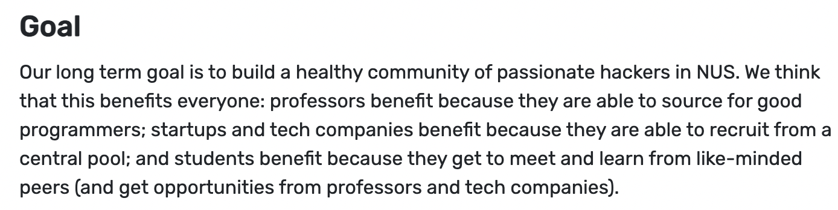

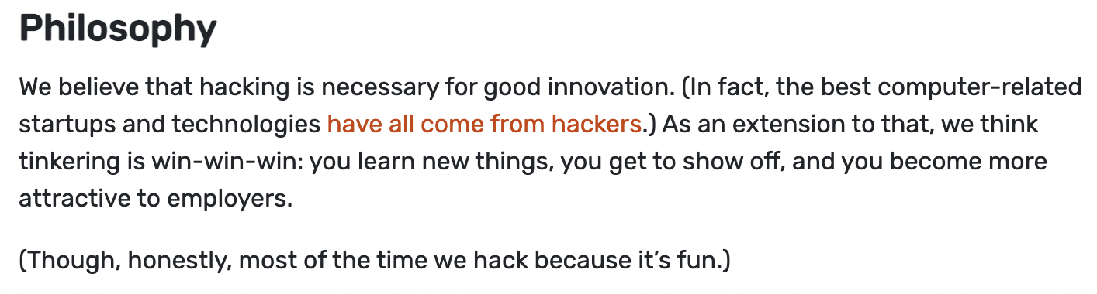

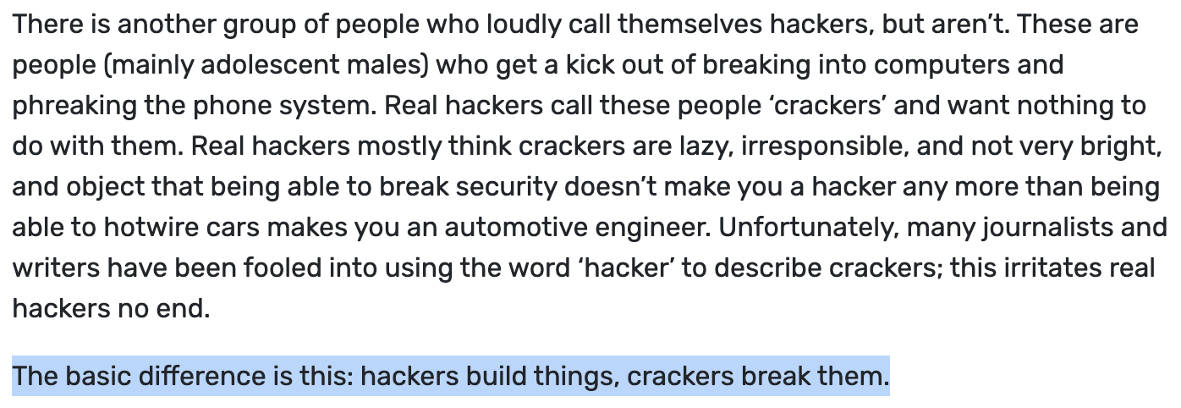

Above are some snippets of the rather colourless NUS Hackers website. The focus of the group’s mission is “fun”, “innovation” and “build[ing] a healthy community”. I was won over to the hacker cause by the loose ideal of “learning for **your** learning’s sake,” since it offered a fresh break from my major’s obsession with personal impact via money-making and job-hunting.

However, hacker culture was not without its flaws. I was not convinced whether learning for learning’s sake was a worthy enough goal. To make matters worse, the website (and Hackers’ events and my classes) often regressed into a capitalism-fuelled individualistic pandering, as evidence by the allure “to become more attractive to employers” or “get opportunities from … tech companies.” The logo --- an abstract male silheoutte in front of a barcode (which we call “Barcode Bob”) subtly pointed to the capitalist problem too. Were we conjuring up visions of Enlightenment-style “learning and fun” only to surrender to the altar of tech companies? Was there no higher ethical goal than mere learning?

My crisis of ethics in learning extended to USP as well, and left me wondering whether simply learning about different disciplines was “enough.” With a crisis in the background, in my second year, I took a biochemistry module at USP, titled “**UPC2208:** **Molecular Courtship.”** The central thrust of the module was to research or find explanations to everyday chemistry phenomena using simple chemistry. However, I gained much more – an understanding that (i) scientific research is incredibly hard, and (ii) the *raison d’etre* of research is ethical, and (iii) an ethical outlook can offer comfort to the researcher in times of distress. In other words, I learnt that we ought to learn and seek explanations not for their sake, but to bring about positive change.

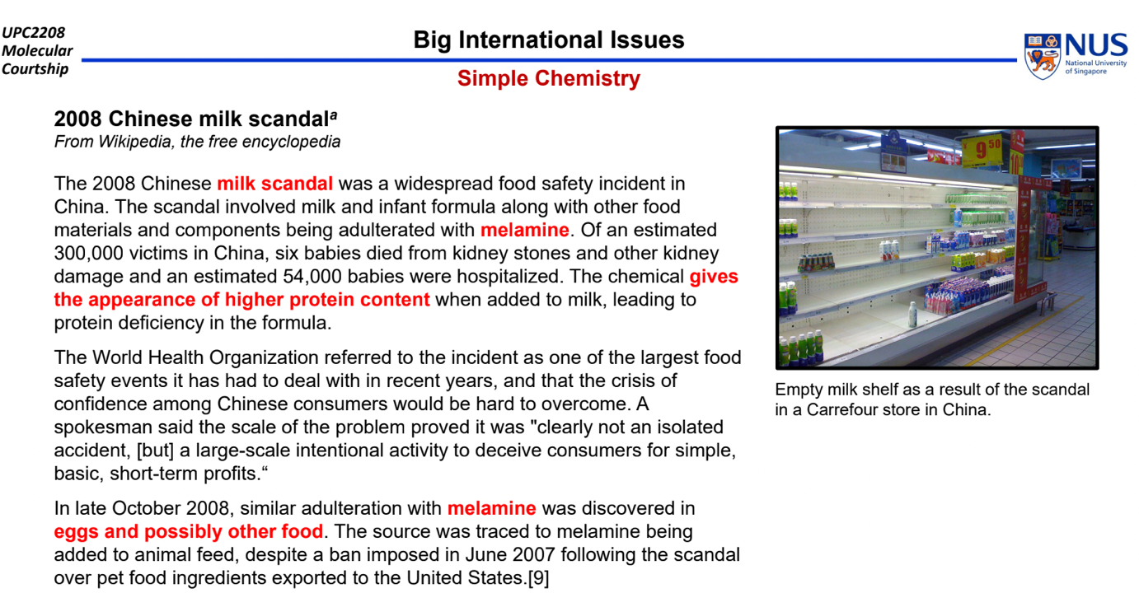

At first glance, both biochemistry and computer science (as seen by hacker culture) seem quite removed from human beings; they seem to harbour the common idiom of disinterested pursuit. However, the ethical idiom in biochemistry was evident from a slide in the very first lecture, shown above. The slide talks about a milk scandal in China, where malicious factories took advantage of an “innovative” chemical melamine, to spoof protein measures and adulterate their produced milk. The incident resulted in the loss of thousands of lives. Interestingly, instead of showing flashy chemical structures and animations about the chemical concepts at play, the professor chose to depict an “empty milk shelf.” The emphasis was on the consequences and human impact of complex chemistry, not just its mechanism.

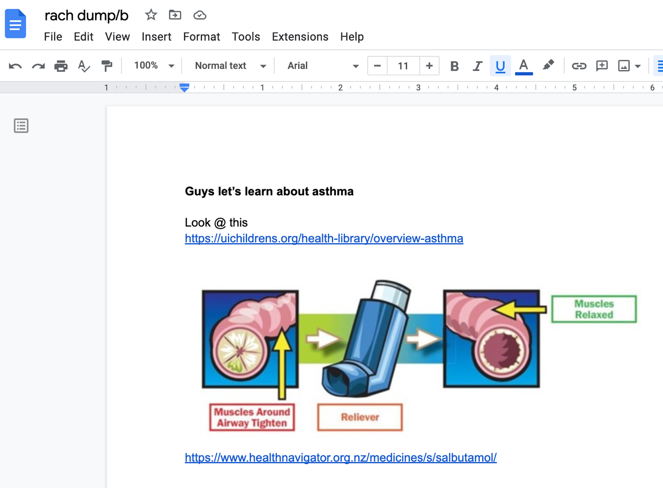

The module continued teaching me the salience of the “ethical” idiom which drives research in biochemistry. The above image shows my groupmate, Rachel’s idea for our group project to explore how asthma works and can be alleviated using inhalers that deliver the salbutamol drug. Rachel marked the objective (“learn about asthma”) in bold and at the very beginning of the document, and was driven by the impact of the inhalers (“muscles tighten / relax”) rather than their chemistry-based mechanism (which we hadn’t even probed yet!).

We didn’t need to discuss much before settling on asthma – we knew friends who had asthma, and the simple image of the inhaler’s action on pulmonary muscles (amusingly akin to a before/after image used in bogus therapies) provided a clear-enough intuition and motive.

Through the project, I learnt that ethics can serve as a good idiom to find important problems in a discipline. I discovered how salbutamol was one of the earliest drugs developed by “rational design,” i.e. it was not accidentally discovered but actively sought after by Sir David Jack, who was obsessed with finding a cure for asthma, and found one after several attempts. I realized the power of having a strong ethical backbone when pursuing research – it guides the researcher to answer truly important questions, pushes them to take risks, and serves as a calming North Star when risks don’t pay off – as is often the case in research.

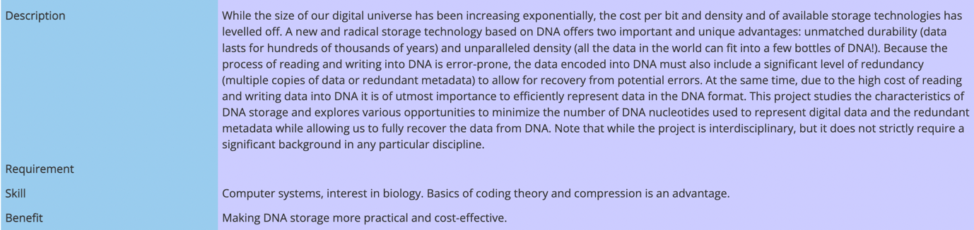

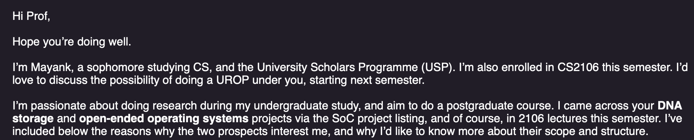





So far, I had envisioned CS as a field bereft of ethical promise, one where important problems are chosen by dint of their personal or industrial impact. Learning about the ethical idiom in biochemistry made me wonder whether a similar idiom might exist in the computer sciences as well. Almost in parallel, I started wondering whether I wondered whether I should pursue research via a postgraduate degree.

To answer my twin questions, I sought out research topics for an undergraduate research project (UROP), and discovered a project about DNA storage, i.e. writing data on DNA molecules (of all things) instead of your regular old flash drives. The DNA project seemed something right out of a sci-fi movie, and I felt it was “the coolest of … projects” because it was (i) capable of vastly improving density and thus reducing energy usage and (ii) extremely risky. The professor, Prof. Djordje Jevdjic, seemed to buy-in to my ethics driven realization – he listed “making DNA storage more practical and cost-effective” as a benefit for students if they embarked on the project – most other projects focused on more individualistic, employer-friendly benefits a la Hackers [1]. I chose to work on the project, and after a lot of failures and pushbacks, I was able to deliver interesting new results about DNA storage in a published paper, and more importantly, I settled on pursuing a career in research.

As I look back, I realize that the simple adoption of an ethical idiom to my approach to computer science inspired me to take the plunge into research. The play, fun, and malleability of hacker culture mixed with the sage ethical slant of biochemistry made for a great first introduction to research.

I’ve finally come to realize the spice behind USP’s vanilla platitude. It takes a *masala* of different idioms distilled by their respective disciplines to form a potent concoction that can tackle the hardest of problems.

**(1314 words)**

**A0200908M**

**Appendix**

The intended audience comprises those who have a good understanding of the USP, its curriculum and importantly, its students.

Below, I include some images which I use as tip-ins which do not merit analysis.

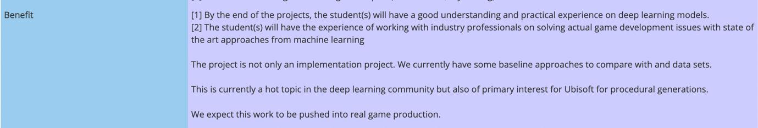

[1] Examples of other project dealing with machine learning and video streaming, whose listed benefits are incredibly student-focused.

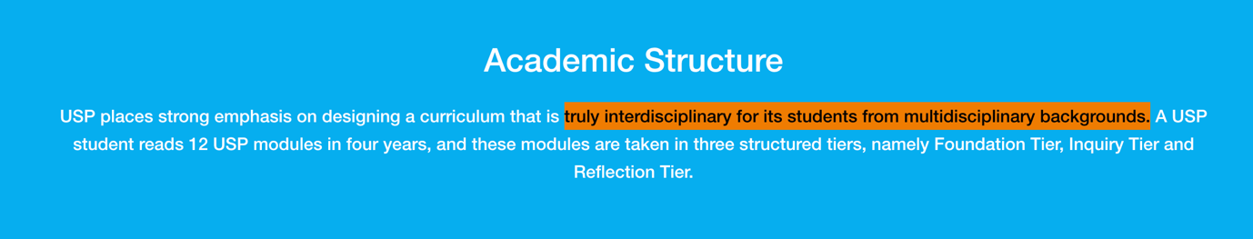

[2] An excerpt from the USP website.

Critical Reflection

Sem 2, AY 2022/2023

Collaborative Reflection

**More Top-Down?**

We live in a time where students have ever-more power in the classroom. The 21st century, capitalism, and its “customer is always right” principle has brought a marked tilt in authority away from the teacher, and toward the student. Grade inflation, flipped classrooms, and student-evaluations are some of the symptoms of this shift. **I don’t quite buy it.**

Personally, I’ve always revered teachers. I prefer classrooms where teachers seize the atmosphere to deliver authoritative lectures, perhaps with a sprinkling of jousting and joking with students. A stern Catholic education and growing up in a “traditional Asian” society are likely culprits and perhaps too problematic; my worship of the “Top-Down Teacher” (and not the “Bottom-Up Teacher”, as I like to put it) has persisted nonetheless.

So ofcourse, when I was blessed with the opportunity to *actually* teach a class, I couldn’t help but don the robes of the Top-Down teacher, the pastor who comes to preach his sermon. I found a partner in crime, Pricllia, and decided to conduct the session together. At this point, a typical reflective essay would reveal its thesis statement: *oh how wrong were* we, and talk about 95 reasons for Reforming the Top-Down Teacher. Well, not quite. This essay is about the Counter-Reformation – about how I learned to go beyond an instinctive bias, and develop a fuller articulation of why the Top-Down Teacher is a valuable asset to a university.

Right from the ideation phase, we realized that a core task of a teacher is to fashion order from chaos. Pricillia suggested that we should conduct a pragmatic session that’d help students for USR, rather than a more expansive session that dealt with broader topics such as reflection, majors, or meta-cognition. We brainstormed several ideas that would make for a fun, breezy yet pragmatic session, hoping that one would *inspire* us and stick. None did. So, in the spirit of faith in our instructor (and a good helping of laziness and desperation), we chose one of the topics mentioned on Canvas:

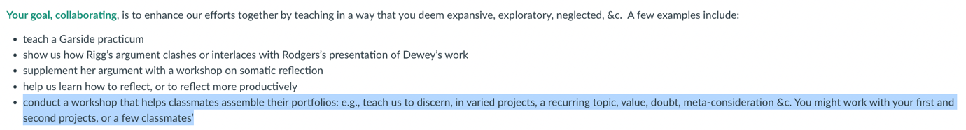



The two highlighted topics jumped out at us. They attacked the difficult problem of crafting meaning from different threads: a task that requires rigour, discipline and authority, i.e. the perfect fit for Top-Down Teachers. Our choice was just blind faith and instinctive choice, not much to call home about.

The planning phase made us realize the benefits (and pitfalls) of imposing authority onto a classroom. We couldn’t possibly deliver “authoritative lecture,” since we simply weren’t experienced enough at reflection to do so. To make matters worse, we’d tried a lecture-like panel earlier in the semester, only to find that it stuck out like a sore thumb amongst the Bottom-Up sessions that our classmates ran, where our classmates acted as facilitators or peers, and not as teachers. Their sessions featured more student interaction, gentler learning curves, classroom exercises, and even crayon-drawings. However, our professor’s feedback during our panel (shown below, colour added), made us realize that our approach wasn’t optimal :

|  |
| --- |
|  |

*Excerpt 1: Prof. Ryan uses the term “teach” instead of “facilitate” or “lead”*

|  |
| --- |
|  |

*Excerpt 2: Our rush to cover “material”. Typical of a school teacher covering their “syllabus”*

|  |
| --- |
|  |

*Excerpt 3: Losing authority (or not) for using ‘like’*

The professor’s comments made clear that if we indeed tried to teach as ***teachers (****see green portion of excerpt 1)*, then we couldn’t afford any slips in authority: rushing, trying to cover “material”, or using inappropriate filler-words (which leads to a loss of authority in regular settings alone, but are even worse when used by a teacher who is supposed to be authoritative). I learnt the hard way that listening to an authoritative lecture is incredibly fun and comforting (since it imbibes the listener with ***closure***), *delivering* one is deeply discomforting, difficult, and painful. It requires a lot more of the speaker than is apparent, as I found out to my chagrin when I introduced a “new idea” at the end of the session:

|  |
| --- |
| Right, it's easy to be wise in hindsight!  If I offer a general rule though, about closure, I don't typically raise a new idea, intro a new thinker, mention a new concept, or otherwise risk upsetting the apple-cart.  Instead, if I'd brought up 'fashioning' at the start, I might have concluded by acknowledging a challenge that you two faced while threading, or that you could imagine cropping up for classmates.  Then, if you offered a way to handle that challenge, you would beef up your lesson's quotient of take-away. |

The professors’ feedback was in line with the body language of the class during our panel (students didn’t ask many questions), and some comments afterwards (“that was a very *zai* (erudite, or show-offy) presentation”). We realized that a simple Top-Down lecture woudn’t work because it was too straight-jacketed and incapable of capturing students’ imagination.

As a compromise, we decided that we’d have a classroom exercise, to inject some student interaction, and not have to “cover material.” However, we added a twist: the exercise would be deliberately contrived and difficult; something akin to a primary school math drill. The exercise would charge classmates with weaving together some excerpts of reflection together to find connective threads. We recognised that doing so within 20 minutes was incredibly difficult, so we devised some mitigatory measures: (i) no homework, (ii) dedicated time in class to first think alone in silence, and then to pair up and discuss, and (iii) choosing excerpts from a man everyone knew and some revered, i.e. Lee Kuan Yew.

|  |
| --- |
|  |

*Excerpt 4: Positive Comments about the structure of the exercise*

Our classmates seemed to agree: they did feel the exercise was both “fun”, “good practice”, a “challenge” and a “push” – exactly what a good drill ought to be. The comment that our workshop ‘timely’ validated our push to be pragmatic. Mitigatory measures paid off too, since classmates mentioned an “awareness of struggles participants might have.” Interestingly, even some elements we *hadn’t* planned were lauded, such as providing well-formatted handouts (shown in yellow).

However, we realized a key pitfall of the Top-Down approach: the teacher fashions an opinionated class with a singular authoritative narrative; and students might not necessarily agree. For instance:

|  |
| --- |
|  |

*Excerpt 5: Problems!*

Clearly, our deliberate and micro-managed approach meant that we didn’t leave enough time for questions; and more worryingly, not enough time for people to share the insights they drew from the difficult drill. That “no one had the chance to ask questions” meant that there *was* a strong desire to do so, something which we did not forecast ahead of time. Additionally, some students “differed” over the value we provided, which is a result of the strongly opinionated class that we pushed. I realized that more open-ended, Bottom-Up classes lead to students crafting their *own* meaning from a class, meaning that in *the worst case,* everyone takes away something, albeit not much. On the other hand, Top-Down classes might provide a lot of value for some students, but others might be lost, “ambivalent” and “find [themselves] asking “so what?”

|  |
| --- |
|  |

*Excerpt 6: Student-driven curiosity translates to teacher-driven insight*

Interestingly, the most important takeaway which ‘stood out’, the “fashioning of reality”, arose as a result of my own skepticism and curiosity about USR, *but as a student*. I was concerned that USR was tasking students to come up with contrived essays that didn’t reflect reality, and were pilfering in “post-hoc rationalization” instead. I went down a rabbit hole, and eventually put forth the argument that the essays we write *create* reality, and are every bit as “real” as the food we eat or the clothes we wear. While my observation was well-received, it stemmed from my curiosity as a student, not as a teacher. I realized that I had hamstrung students from exercising their own curiosity in my class, by denying them a better Q&A) fashion. This pitfall is not just my own; it is part of a broader problem with Top-Down Teachers, who cannot foresee the interesting responses that students might have to their class.

Anyway, let’s sum up, class. In an age where the University is increasingly being transformed into a comfortable bootcamp to train jobs, my experiences taught me that the Top-Down Teacher maintains a sacred role: to cause discomfort, inspire growth, unsettle the mind, and push students. After all, university isn’t about learning skills that we are comfortable learning, but to thrive in situations where we’re thrown off.

(1310 words)

A0200908M.

1. *Ketupat* is an affectionate term colliquially used to refer to USP’s logo.